# A Project on EId Festival (Scenario)

Course: Computer Graphics

Section –F

Fall-2020-2021

Group Members

|  |  |  |
| --- | --- | --- |
| SL No. | Name | ID |
| 1 | Sadek Islam | 17-35436-3 |
| 2 | Erfanul Haq | 17-35338-3 |
| 3 | Md,Shefatul Islam | 18-36389-1 |
| 4 | Nafisa anjum | 18-38091-2 |
| 5 | Tarif Sadman | 18-36466-1 |

**American International University -Bangladesh**



**Objective**

Scenario With Eid festival is a computer graphics project where a city is designed in two modes “Day Mode” and “Night Mode”. This project is about to introduce with the city Eid Enviroment. Though it is a graphic based project, we designed it as an animation. It is functional, colorful and animated. We have created some artifacts on this project like- sun, eid moon, clouds,rain, rivers,train,festive mode etc. Some animations are automatic and some are keyboard pressable .

**Methodology / System Implementation Method**

We have written the on code blocks in C++ and make the project with OpenGL & GLUT basics. OpenGL is a type of low-level graphics rendering API. It Generate high-quality color images composed of geometric and image primitives. We have use RGB color codes as elements color. We have use different primitive to make different shapes.

Different algorithm such as DDL algorithm mid Point Line algorithm mid-point circle algorithm has been used to make perfect pixel elements. Again Translation Scaling Rotation (Clockwise and Anti-Clockwise) has used to increase, decrease, move and rotate elements. Also Homogeneous 2D, Transformation, Mirror Reflection, Scan conversation, clipping, Bezier Curves and RGB Colors has used in our project.

We have added some Keyboard pressable animation such as by pressing ‘n’ the scenery changes from day to night in our night version the color of the sky changes. stars are added, eid moon rises.Again by pressing the key ‘d’ the train will go forward and moving, with 'a' trains moves to backword.With 's' Train will stop . By pressing ‘R’ rain will start.By pressing ‘E’ it will stop,

**Significant of the Project**

We have learnt a lot of graphics features during this course and project. We come to know about GLUT, OpenGL, all the graphics library, utilities and toolkits. We come to know the use of primitive, RGB color code trough this project. We leant different types of algorithm and their uses. Now we know how to animate, make shapes, move or rotate elements with codes. Also come to know about pixel, resolutions, rasterization, different clipping, 2D transformation, mathematical function for animation and their uses.

**Conclusion**

Without any doubt it was a very amazing and knowledgeable course. We have learnt and able to use all the function to create a graphics interface using GLUT and C++. It was a very fruitful project as we get a chance to implement all the knowledge from the computer graphics course. Through this project we come to know about our limitations and ability. We will definitely implement and increase our gained knowledge and skills in future.

**Referencing**

* Course slide
* Sample Project 2
* <https://www.youtube.com/watch?v=aG9VLRFa-2k>
* <https://www.youtube.com/watch?v=RGB-wlatStc>
* <https://en.wikipedia.org/wiki/Rasterisation>
* <https://www.tutorialspoint.com/computer_graphics/line_generation_algorithm.htm>
* <https://www.gatevidyalay.com/2d-transformation-in-computer-graphics-translation-examples/>
* <https://en.wikipedia.org/wiki/B%C3%A9zier_curve>
* <https://en.wikipedia.org/wiki/Clipping_(computer_graphics)>
* <https://www.onlinestudy.xyz/2019/06/clipping-in-computer-graphics.html>
* <https://rgbcolorcode.com/color/dirt>

**Screenshot of the System**

Day view of city

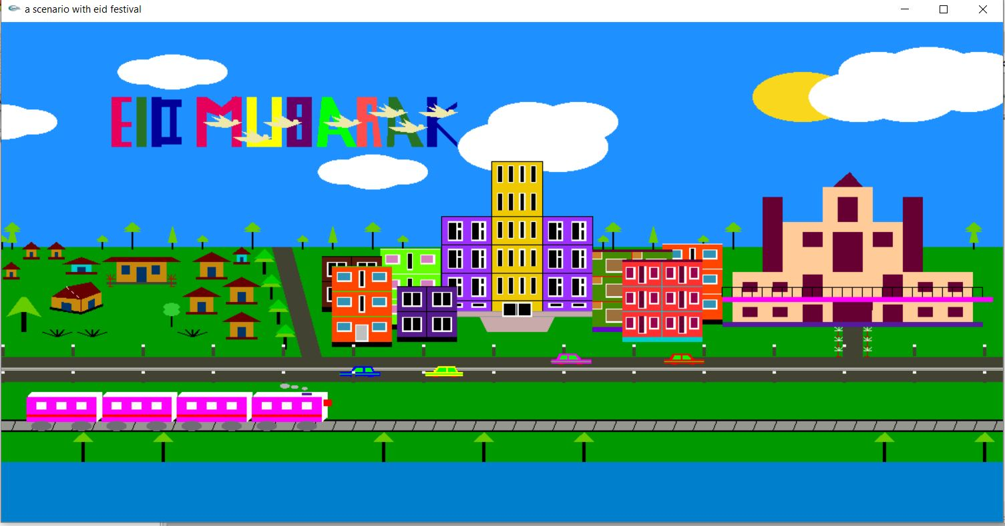

Night view of city

